Task 1-DWH should be tested based on the provided DWH_schema.pdf and DWH_schema_description.docx (same as in Data Mapping task) and test cases from previous HW.

1-Check DWH table existence

In 3_create_DWH_layer_postgres.sql, the following DWH tables are present:

* dwh_clients
* dwh_products
* dwh_sales
* dwh_channels
* dwh_locations

2-Validate column names and data types in DWH tables

Column names and types match expectations. Example:

* dwh_clients.client_id is INTEGER (PK)
* dwh_products.product_cost is NUMERIC(18,2)
* dwh_sales.order_completed and order_created are DATE

3-Validate DWH_CLIENTS has data

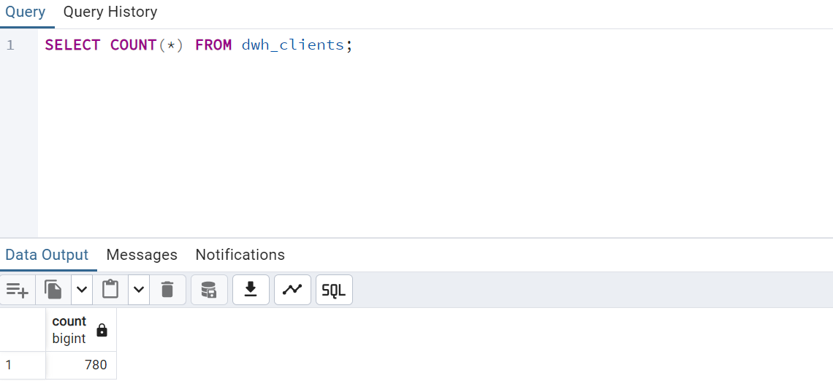

4-check key fields for nulls in DWH_SALES

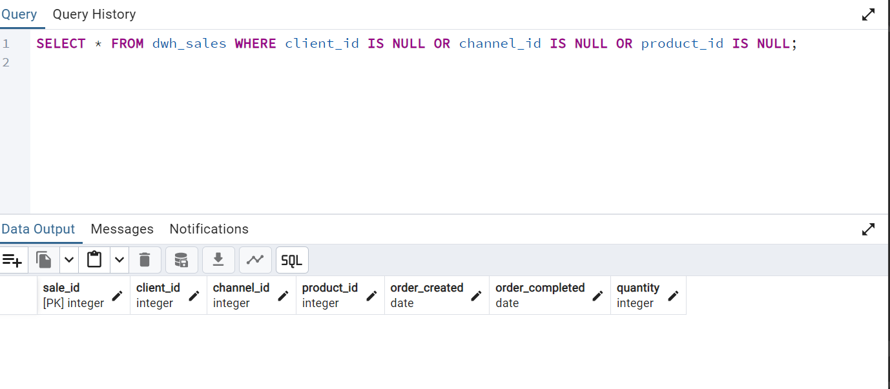

5-Validate TOTAL_COST matches PRODUCT_COST × QUANTITY

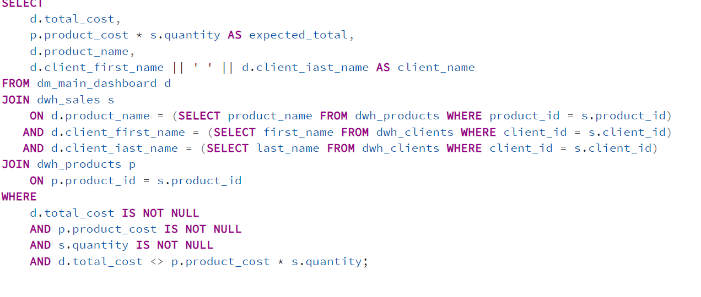

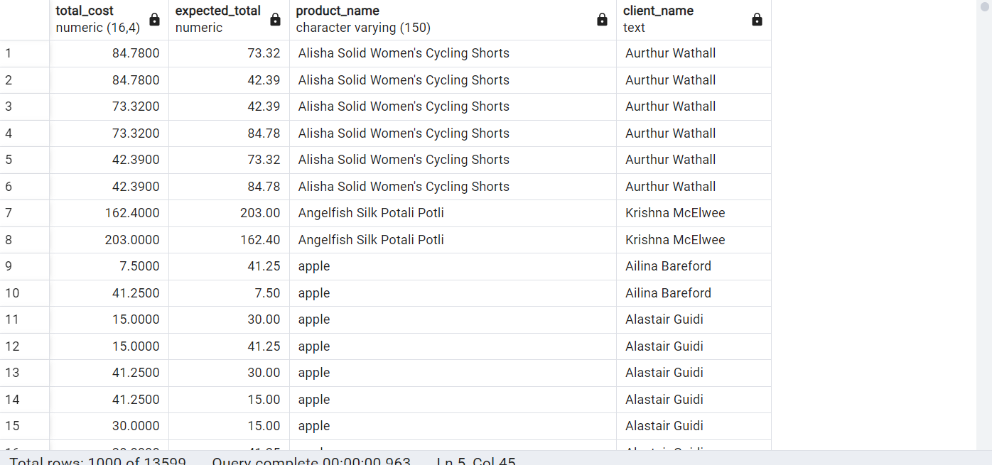

6-Detect duplicate sales records

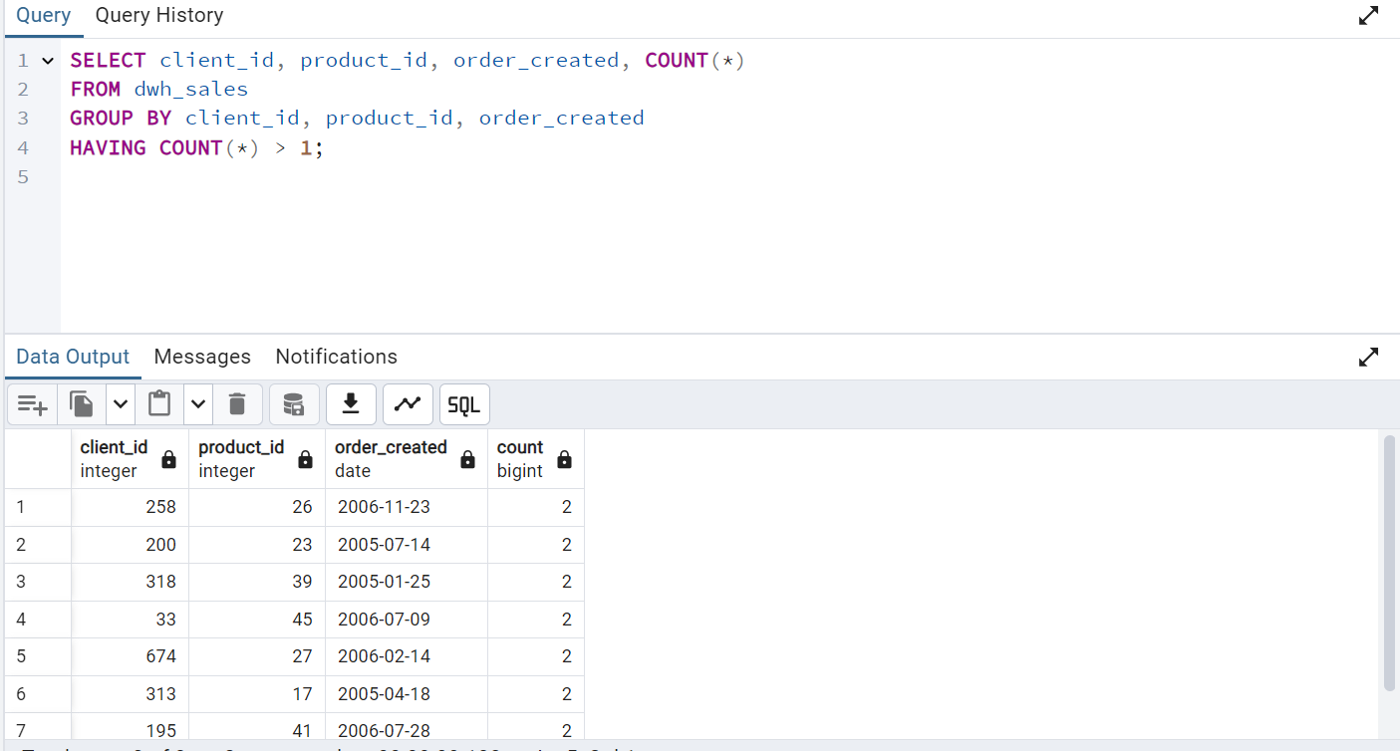

7-Check phone number format in DWH_CLIENTS

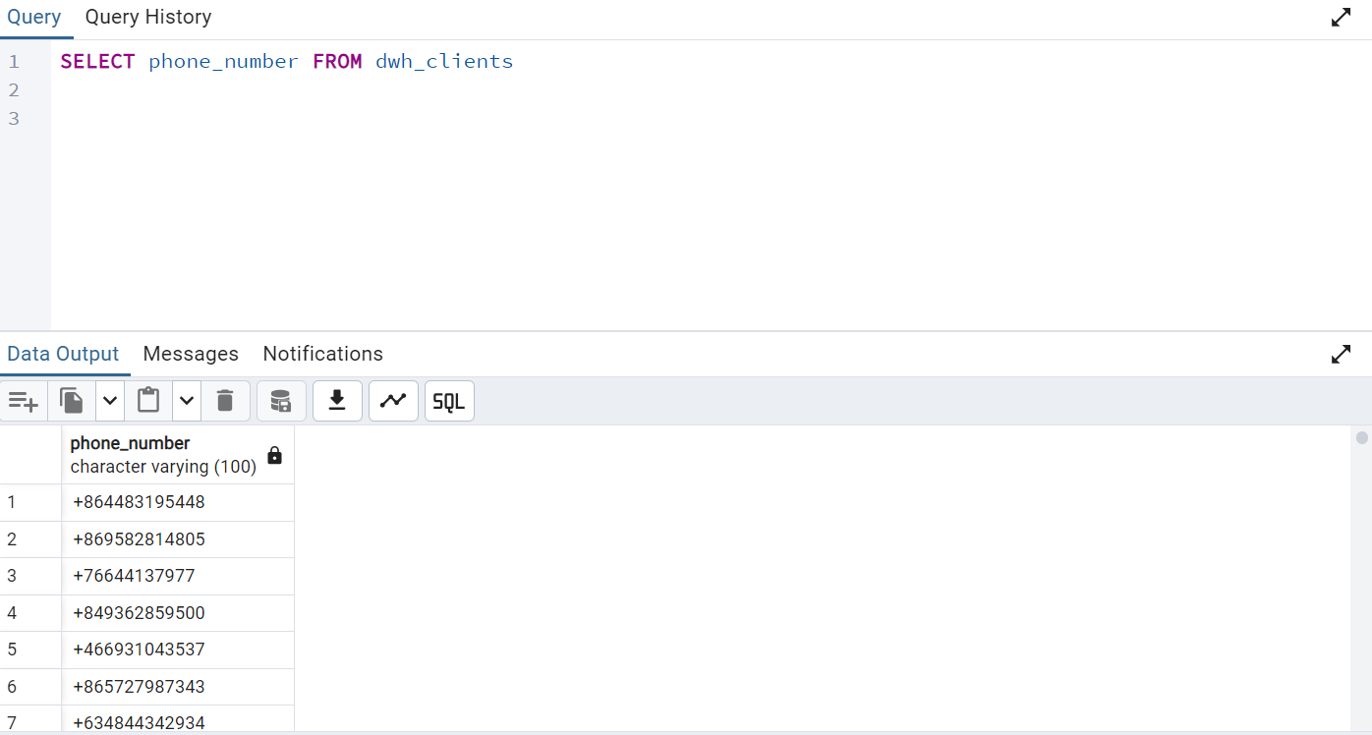

8-Match record counts between source and DWH

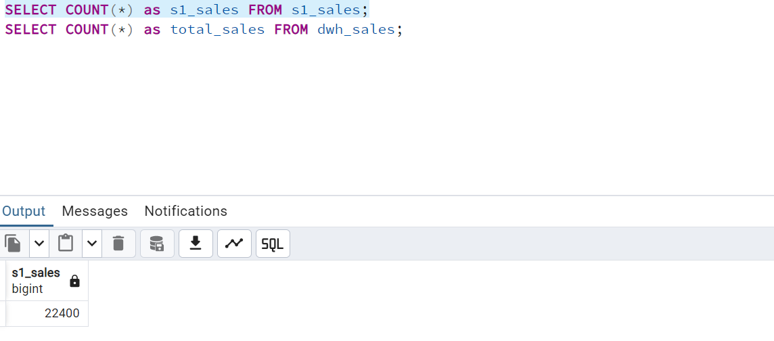

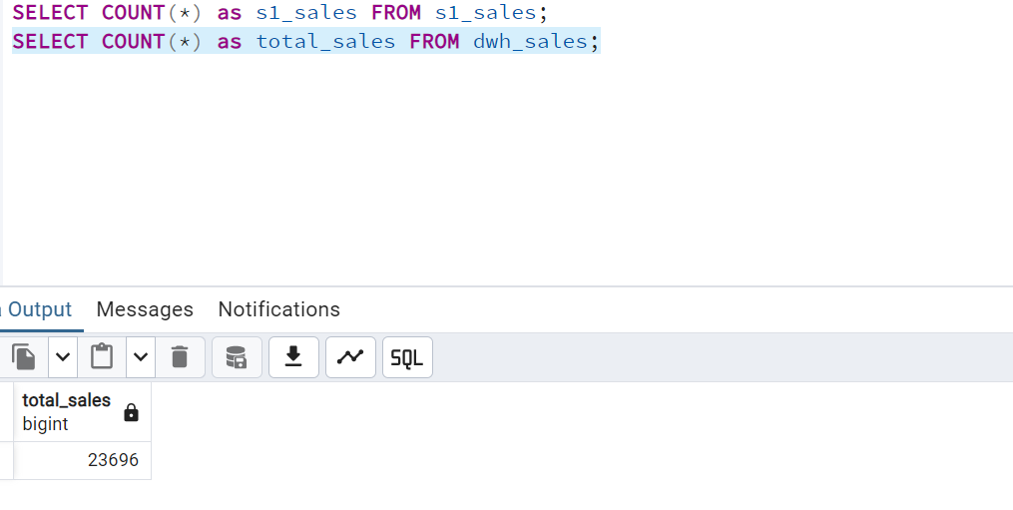

9-Check client name and email consistency post-transformation

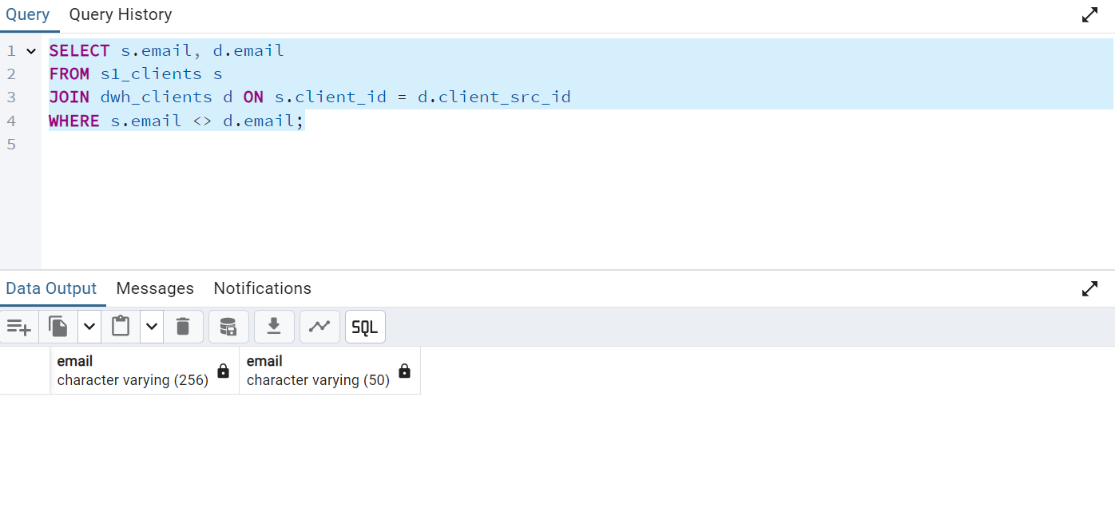

Since this return no rows that means that src_id and cliend_id are correctly transformed

10-Validate mandatory fields are not null in DWH_CLIENTS

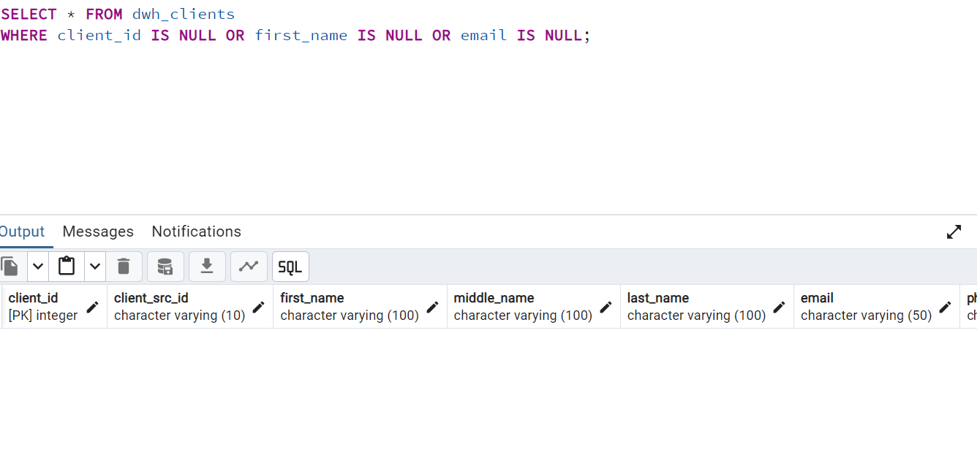

11-Ensure ORDER_COMPLETED ≥ ORDER_CREATED

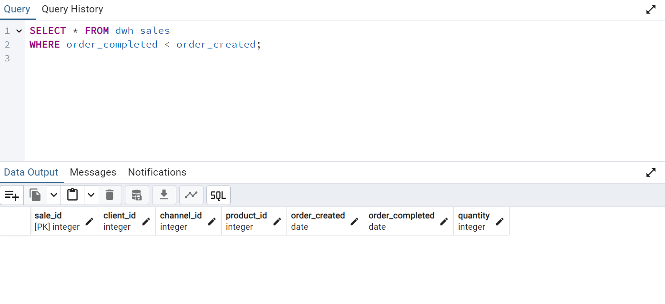

So all tests are passed except the 8,6 and 5—these are the links to them

Test 5-<https://daeglobalau24dq.testrail.io/index.php?/cases/view/3464&group_by=cases:section_id&group_order=asc&display_deleted_cases=0&group_id=381>

Test 8-<https://daeglobalau24dq.testrail.io/index.php?/cases/view/3466&group_by=cases:section_id&group_order=asc&display_deleted_cases=0&group_id=381>

Test 6-

<https://daeglobalau24dq.testrail.io/index.php?/cases/view/3465&group_by=cases:section_id&group_order=asc&display_deleted_cases=0&group_id=381>

this is the link to jira-<https://daeglobalau24dq.atlassian.net/jira/people/712020:027b4827-e3a8-40d3-8cf8-9f657dc839ca> and two of them are in ‘to do’ category.